Take our quiz and find out how good a sleeper you really are
(and were)...

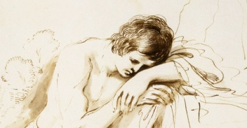
How to get a good night’s sleep in the seventeenth century...

- Tie a slice of bread soaked in vinegar to the sole of each foot. True False

- Make sure your window exposes you to plenty of moonlight. True False

- Wrap up your head warmly. True False

- Always go to sleep barefoot. True False

- Get up at midnight and stay awake for two hours. True False

- Keep your mouth closed when you’re asleep. True False

- Have a relaxing lie-in at the weekends. True False

- Make sure you always go to sleep on your right side. True False

- Place fragrant aniseed under your nostrils as you drift off. True False

- Have a bowl of onion or leek soup before bed. True False

1-3 correct answers: Thou shalt be plagued with watching...
4-6 correct answers: Some work thou hast still to do.
7-10 correct answers: Thou shalt sleep sound.

Answers: 1. True; 2. False; 3. True; 4. True; 5. True; 6. False; 7. False; 8. True; 9. True; 10. False
Now turn ye the page...
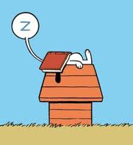

How to get a good night’s sleep in 2015...

- Read a good novel in bed on your iPad. True False

- Have a couple of glasses of wine. True False

- Get up at the same time each day, including weekends. True False

- Watch TV in bed before turning out the light. True False

- Take a brisk walk an hour before bed. True False

- Spend plenty of time outside during daylight. True False

- Don’t get out of bed during the night if you can’t sleep. True False

- Finish dinner at least four hours before bedtime. True False

- Avoid bright light as you’re preparing for bed. True False

- Avoid naps during the day. True False

1-3 correct answers: Your sleep hygiene needs attention... make time for yourself!
4-6 correct answers: Not bad - but remember to prioritise your sleep... you’ll feel the benefit.
7-10 correct answers: Well done. Sleep tight!

Answers: 1. False; 2. False; 3. True; 4. False; 5. False; 6. True; 7. False; 8. True; 9. True; 10. True

www.watching.eca.ed.ac.uk

